**AWS Server Migration Service (SMS)**

* Note: AWS is discontinuing this service as of March 2022 and is recomending to use AWS Application Migration Service (AWS MGN) as the primary migration service fro lift and sshift migrations
* Using AWS SMS we can migrate from
* VMWare VSphere
* Hyper-V
* Azure
* Using AWS Migration Service we can migrate applications from
* Physical Infra
* VmWare vSphere
* Hyper-V
* Other Clouds
* Server Migration Process using SMS  
  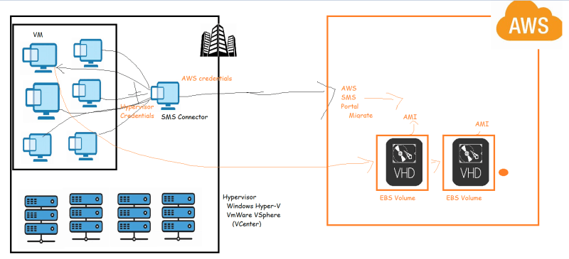
* AWS has acquired an Organization Cloud Endure => Migrate to AWS [Refer Here](https://docs.aws.amazon.com/prescriptive-guidance/latest/migration-cloudendure/welcome.html)
* Now the recomended approach is to use Application Migration Service.
* Simulating the on-premises migration.
* We will be used a Nested Virtualization Supported Windows VM from Azure as our source.
* [Refer Here](https://www.youtube.com/watch?v=MdDOc9OPVDA&list=PLuVH8Jaq3mLuqXuGs6aeqxhuvCYSzB1kT) to create Azure Account
* [Refer Here](https://www.youtube.com/watch?v=P9X-4Z-NeGg&list=PLuVH8Jaq3mLuqXuGs6aeqxhuvCYSzB1kT&index=2) for creating vm in Azure